**University POLITEHNICA of Bucharest**

**Faculty of I.M.S.T**.

Technical documentation

44

UPBAIR1

XII. International Aventics Pneumobile Competition 2019 – powered by Emerson

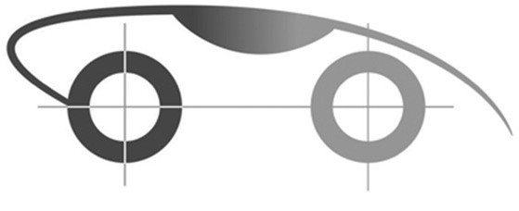

Contents

2 Technical data sheet 3

3 Safety regualations 4

3.1 Accenpting the general safety rules 4

3.2 Presentation of the dimension-related rules (Drawing is mandatory) 6

3.3 Mounting and protection of pressure tank (Drawing is mandatory) 8

3.4 Mounting and protection of buffer tank (Drawing is mandatory) 9

3.5 Engine placement (Drawing is mandatory) 10

3.6 Brakes 11

3.7 Turning Radius (Drawing is mandatory) 13

4 Presentation of vehicle 14

4.1 General information about the Pneumobile 14

4.2 3D model of the vechicle 16

4.3 Dimensions 18

4.4 Chassis, CAD model 18

4.5 Design of body, starting plates 20

5 Engine and drive chain 22

5.1 Engine construction 22

5.2 Drive Chain 23

5.3 Calculation 23

6 Control system 27

6.1 Pneumatic scheme 27

6.2 BOM of Pneumatic scheme 28

6.3 Electronic scheme 30

6.4 Details of the control system 31

7 Suspension, brake and steering system 35

7.1 Front wheels 35

7.2 Rear wheels 36

7.3 Steering system 36

8 Innovation 37

# Technical data sheet

# 

|  |
| --- |
| 2322 |
| 1240 |
| 68,5 |
| 1600 |
| 1260 |
| 4 |
| 520 |
| 2 |
| 2 |

|  |  |  |  |
| --- | --- | --- | --- |
| **AVENTICS PNEUMOBIL 2019 TECHNICAL DATA SHEET** | | | |
| **START NUMBER: NAME OF TEAM:**  **NAME OF UNIVERSITY:** | | 44 | |
| UPBAIR1 | |
| University Politehnica of Bucharest | |
| **TEAM-MEMBERS** | | | **Year/class:** |
| Mr. Barbu Andrei | | | 2 |
| Mr. Necula Eduard-Florin | | | 2 |
| Mr. Deac George Antoniu | | | 3 |
| Mr. Bodog Mircea | | | 1 |
| Mr. Agud Mihai | | | 2 |
|  | | |  |
| **NAME OF SUPPORTING INSTRUCTOR:** Dr.dipl.eng. Mihai GHINEA | | | |
| **YEAR OF THE VEHICLE WAS BUILT** | | | **2020** |
| **VEHICLE VERSION** NEW/REBUILT | | | **New** |
| **PLANNED TOP SPEED**  **PLANNED OPERATIONAL DISTANCE** | | | 52.61 km/h  11240 m |
| **MAIN FEATURES OF THE PNEUMOBILE**  LENGTH WIDTH MASS AXLE-BASE  TRACK WIDTH NUMBER OF WHEELS  DIAMETER OF STEERED WHEEL(S DIAMETER OF DRIVEN WHEELS NUMBER OF DRIVEN WHEELS | | | mm mm kg mm mm pcs mm mm db |
| **ENGINE-CONSTRUCTION** | Pawl | | |
|  | | | |
| **CONTROL SYSTEM** | PLC Control | | |
| **FEATURES OF THE PNEU-ENGINE**  NUMBER OF CYLINDERS IN THE ENGINE  CYLINDER DIAMETER  STROKE DISPLACEMENT  RPM OF THE ENGINE-AXLE TORQUE OF THE ENGINE | | | db mm mm cm3 1/min Nm   |  | | --- | | 2 | | 50+63 | | 320 | | 628+997 | |  | |  | |

# Safety regualations

## Accenpting the general safety rules

Undersigned Mr. Ghinea Mihai teacher, from the University Politehnica of Bucharest, as supporter teacher, declare that I have checked the technical documentation of the vehicle. Our team is committed to paying particular attention to the following guidelines when designing and constructing a vehicle. By submitting the technical documentation, we accept that non-compliance with the points of section 2 of the design documentation may result in disqualification.

Additionally I declare that the members of team have made the technical documentation.

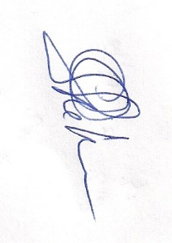28.12.2019 Assoc.Prof.Dr.Dipl.Eng. Mihai GHINEA

Signature

* + 1. Wearing a head protection helmet is obligatory.
    2. If the helmet does not have plexi to protect the face, it is obligatory to wear goggles.
    3. Drivers have to wear closed shoes and gloves.
    4. Drivers should wear long sleeve clothing (tops/shirts) and long trouseres during all races
    5. All the safety functions need to be in the driver’s reach.
    6. Driver should sit in a seat equipped with a four fixing position belt, that is able to fasten the driver so that the shifting is prevented.
    7. Drivers have to be able to leave the car within 15 seconds and they have to be able cut off the voltage and compresed air supply of the vehicle.
    8. Vehicle must be equipped with two rear-view mirrors
    9. The vechicle must be equipped with an electrical safety switch, which can be operated from the outside.
    10. The electrical emergency swith must be marked with red-white triangle (red frame, white inside).
    11. Using of the predesigned pneumatic safety circuit is obligatory.
    12. Safety circuit should be mounted on red plate and placed in such place that allows easy access to it for driver and from outside of vehicle.
    13. The frame must protect the driver’s leg.
    14. The battery must be placed in an IP54 protection class casing, which prevents the batteries from moving.

Signature of Team Members

|  |  |  |
| --- | --- | --- |
| **TEAM-MEMBERS** | **Year/class:** | **Signature of Team Members** |
| Mr. Barbu Andrei | 2 |  |
| Mr. Necula Eduard-Florin | 2 |  |
| Mr. Deac George Antoniu | 3 |  |
| Mr. Bodog Mircea | 1 |  |
| Mr. Agud Mihai | 2 |  |
|  |  |  |

## Presentation of the dimension-related rules (Drawing is mandatory)

Maximum allowed lenght: 2500 mm – Vehicle lenght: 2322 mm;

Maximum allowed width: 1700 mm – Vehicle lenght: 1240 mm;

Maximum allowed height is 90% of width – Vehicle height: 980 mm which represent 77% of width;

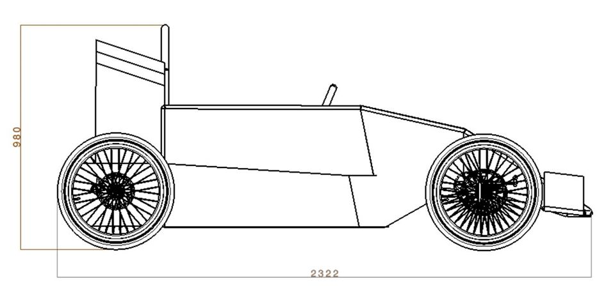

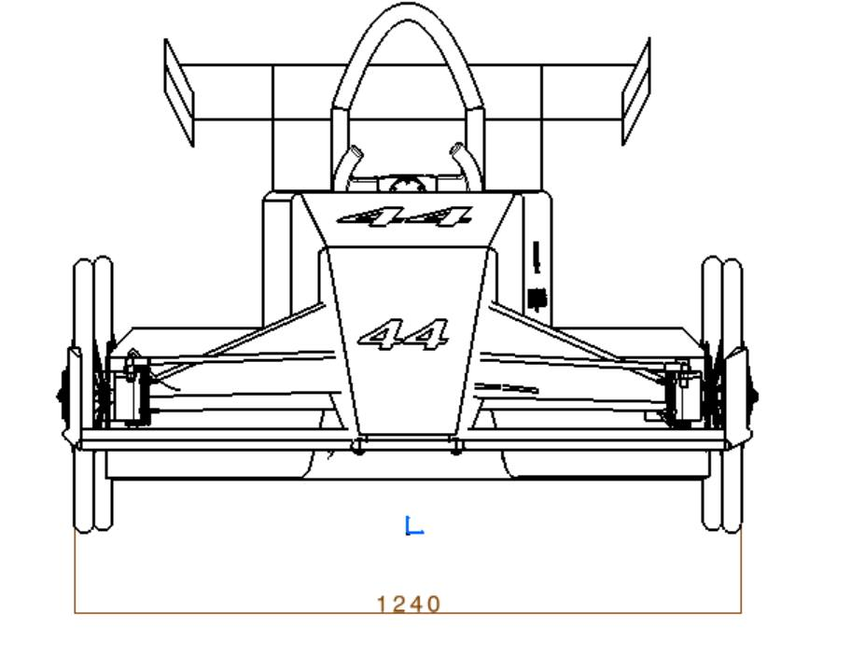

The clearance between the bottom of vehicle and ground surface must be al least 70 mm – Vehicle clearance between the bottom of vehicle and ground: 98 mm

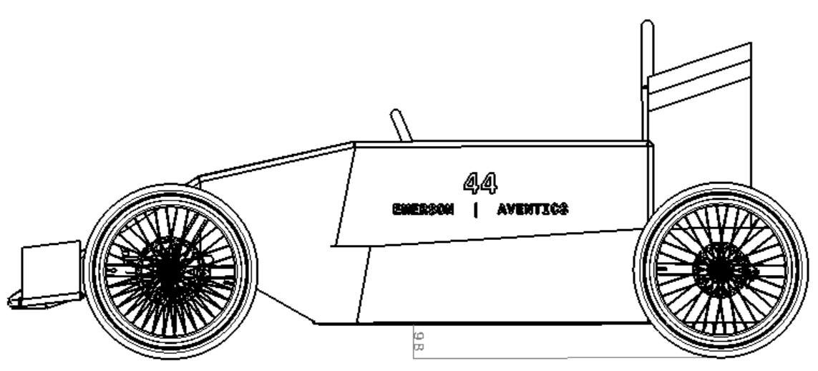

Tank and pressure reducer are not higher than 50% of vehicle wheelbase.

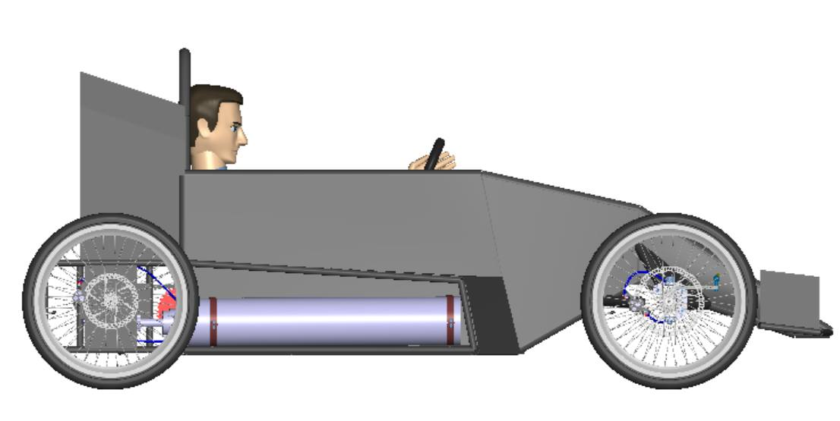

The highest ponit of the engine is not higher than 60% of the with.

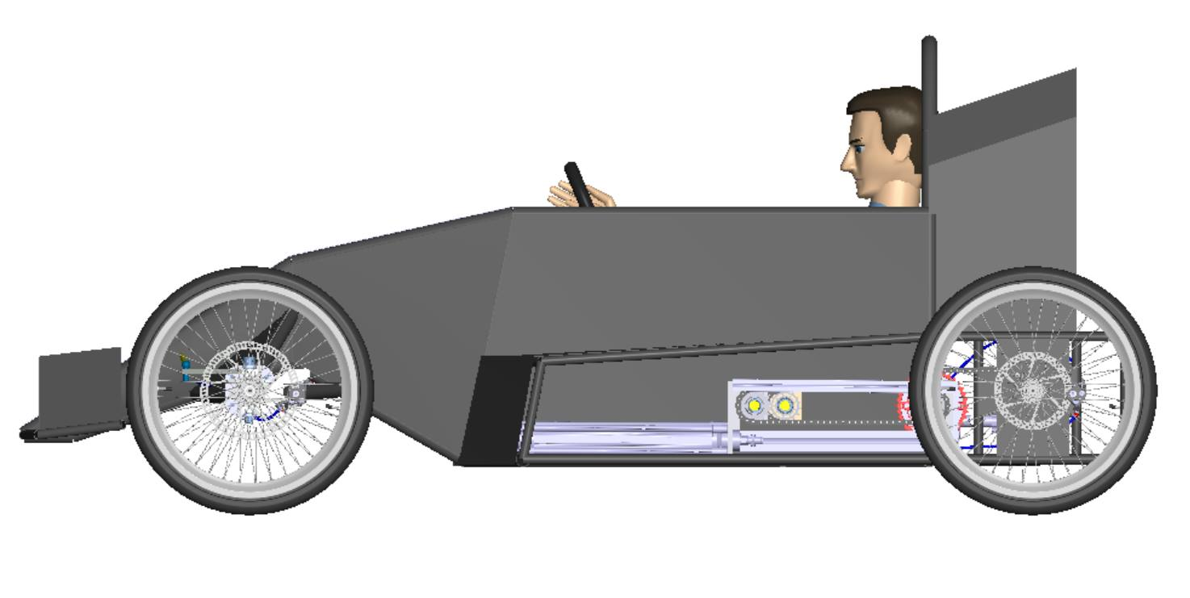

The engine is placed in the vehicle and it`s not extend out of vehicle.

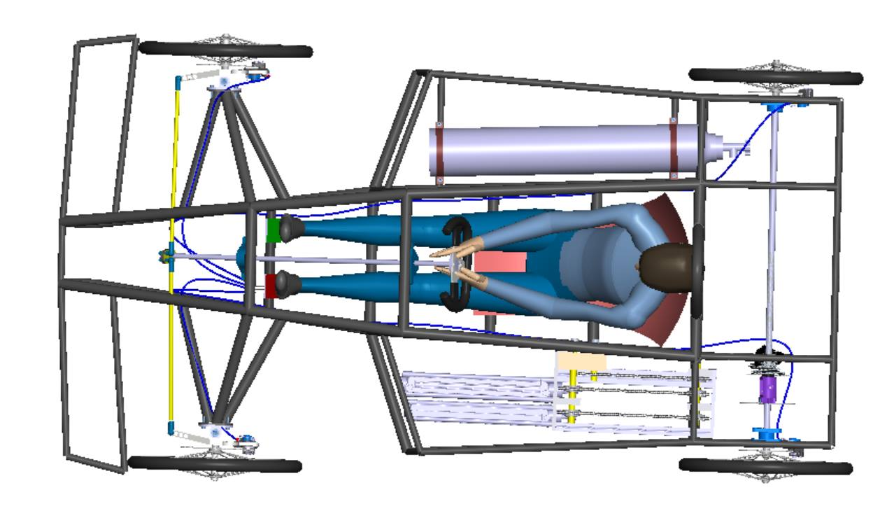

## Mounting and protection of pressure tank (Drawing is mandatory)

The pressure tank in is mounted in the right side of the vehicle. Is in the frame, separated from driver`s habitat with a 3 mm aluminium sheet. The tank is fixed with two metal clips that provide a firm grip.

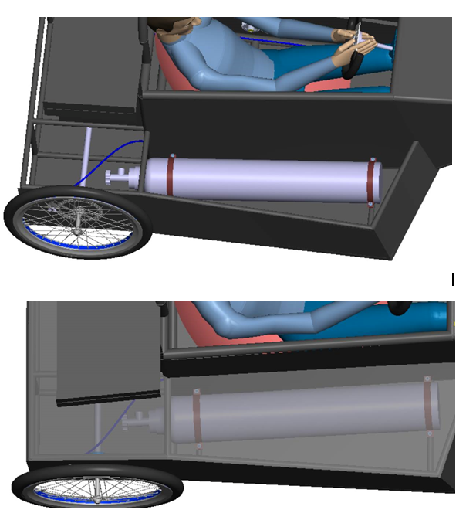



## Mounting and protection of buffer tank (Drawing is mandatory)

We have a buffer tank whose capacity is 20l and will be mounted behind the driver.

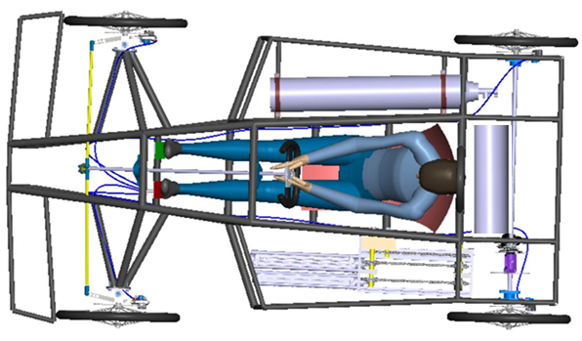

## Engine placement (Drawing is mandatory)

The engine is on the left side of the vehicle. It is in the frame, separated from the driver's habitat by a 3 mm aluminum sheet. All engine components are fixed.

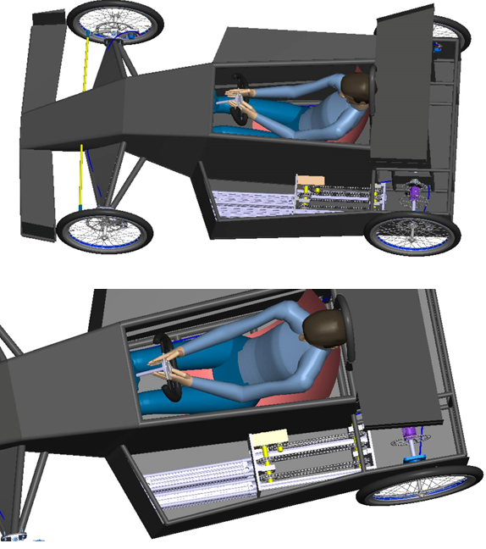

## Brakes

The vehicle has bicycle disc brakes. All the wheels of the vehicle have brakes that are pressed with a pedal, with the left foot.

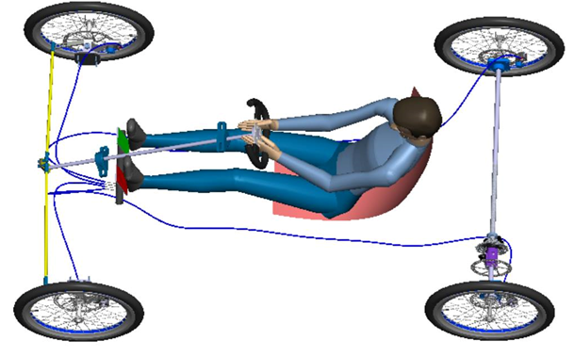

The brakes system

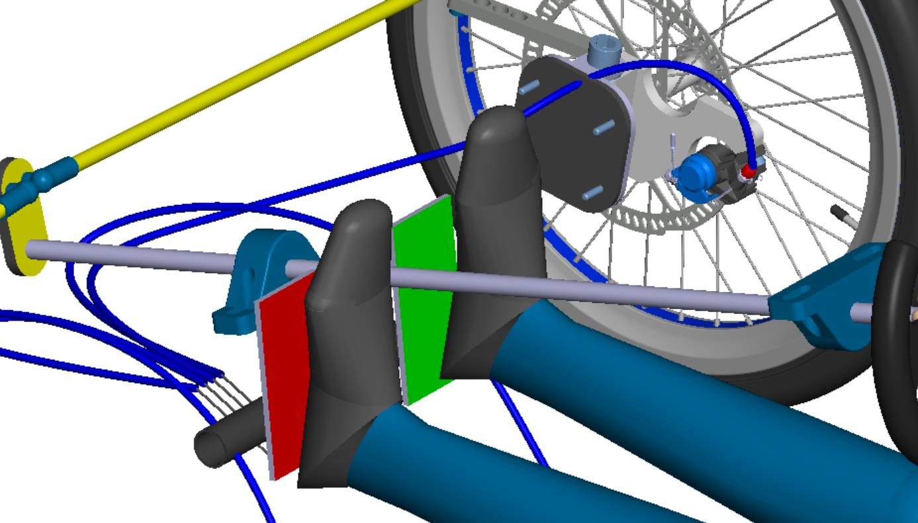

Pedal system for brakes

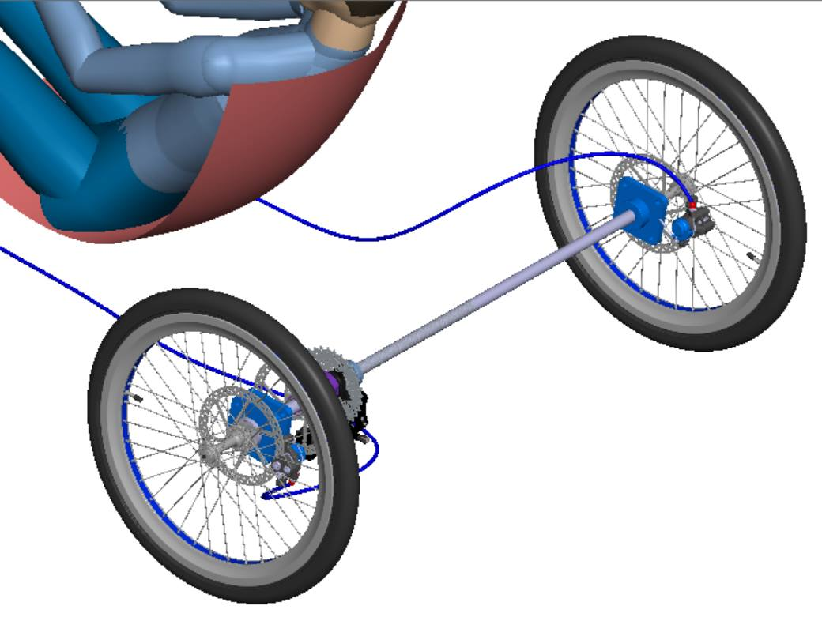

Rear brakes

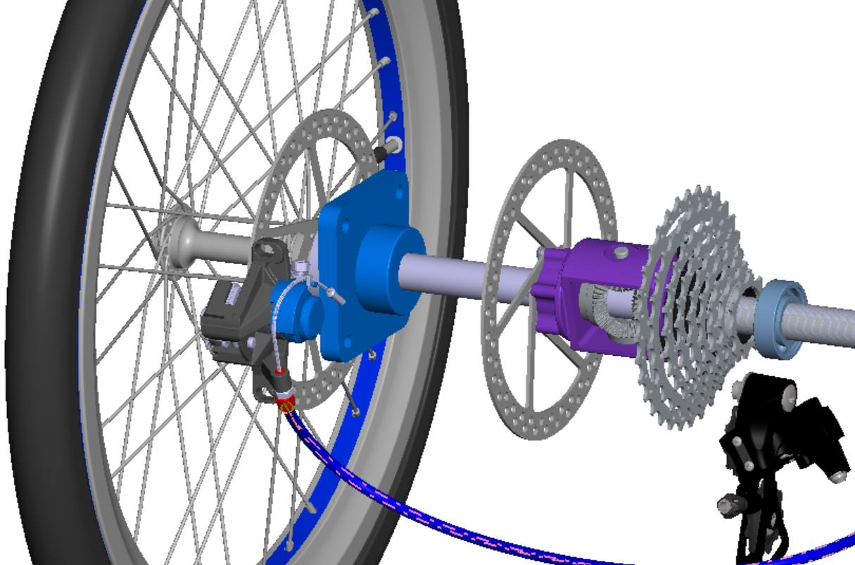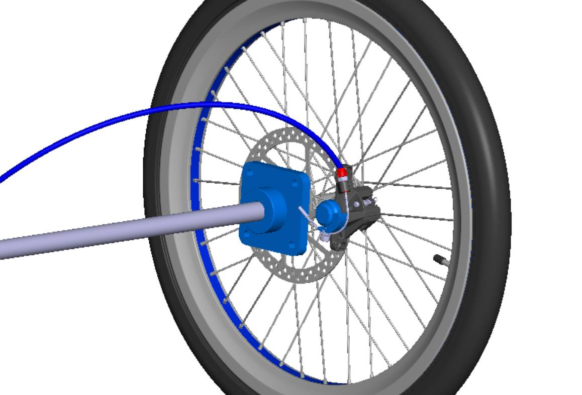

Rear left brake Rear right brake

## Turning Radius (Drawing is mandatory)

Calculation of corner stability of the vehicle

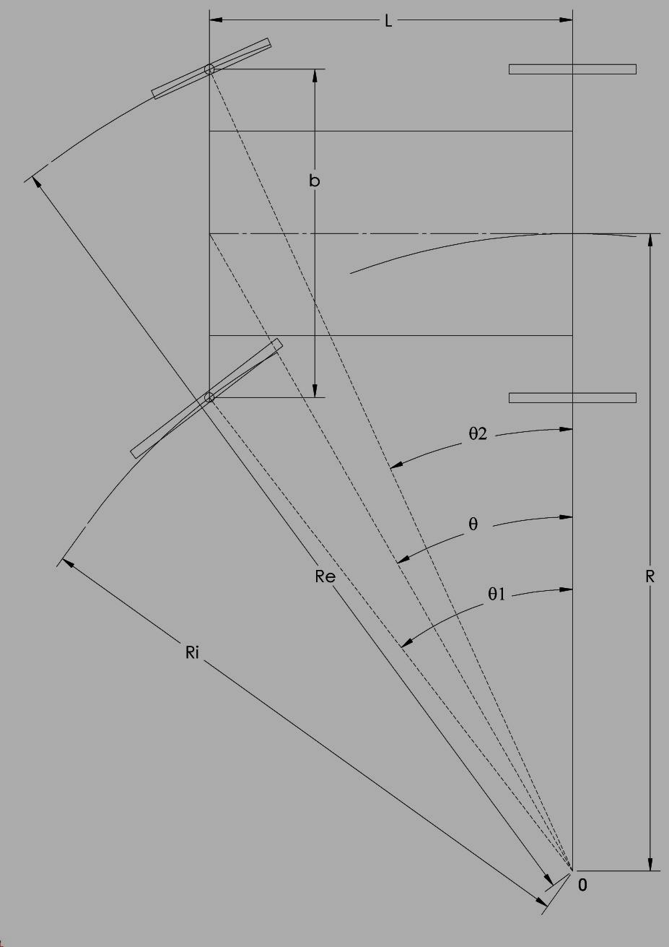

$$ctgθ_{2}-ctgθ_{1}=\frac{R+\frac{b}{2}}{L}-\frac{R-\frac{b}{2}}{L}=\frac{R}{L}=ct$$

For Re radius the equation is:

$$R_{e}=\frac{L}{\sin{θ_{2}}}$$

$$R_{e}=\frac{1700}{\sin{2}9}=3600mm$$

Re = 3600 mm

* For Ri

$$R_{i}=\frac{L}{\sin{θ_{1}}}$$

$$R_{i}=\frac{1700}{\sin{3}6}=2892,6mm$$

Ri = 2892 mm

As it can be seen the turning circle is smaller than 8m.

The vehicle turn in maximum 6,7 m.

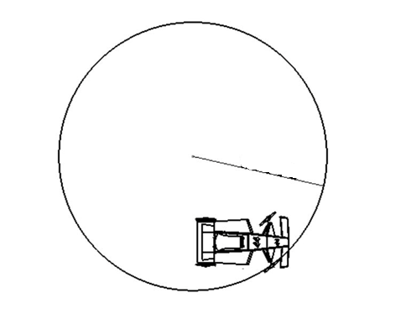

Ri=2892

# Presentation of vehicle

## General information about the Pneumobile

The vehicle of our team, Upbair1, which represents the University POLITEHNICA of Bucharest, is an experimental vehicle with compressed air, designed to participate in the race "PNEUMOBIL 2019", organized by Aventics.

The car is a vehicle that was designed to obtain maximum performace. It has 2 rear wheels that push the car and 2 front wheels that turns the car. The engine is composed of two pneumatic pistons(fi63x320 stroke and fi50x320 stroke), disposed one in the opposite direction of another, which are controlled by electronic valves. The liniar motion is transformed in rotation motion by pawls, which tranform the motion from both ways. It is transmitted with a bike shifter with 10 speeds mounted on differential.

For the best performance we designed the chasis as a formula 1 car. It has a light chassis and a good aerodynamics. The chassis is made by aluminium tubes(mm x mm). Body panels are made by ABS for weight reduction.

The braking system is composed by mechanical bicycle brakes.It is made up by 4 disk brakes, one on each wheel and 4 calipers, all of them actionated by one pedal.

To control the electric system we are using one PLC (Programmable logic controller) from emerson and for the intake of pistons is used electro-pneumatic valves controled by PLC.

## 3D model of the vechicle

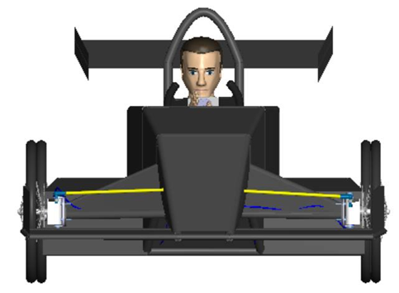

Front view of the vehicle

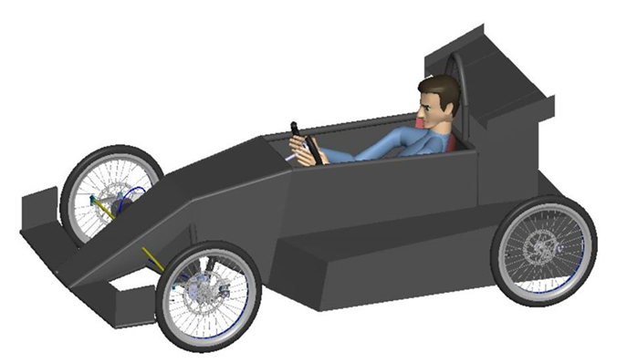

Perspective view of the vehicle

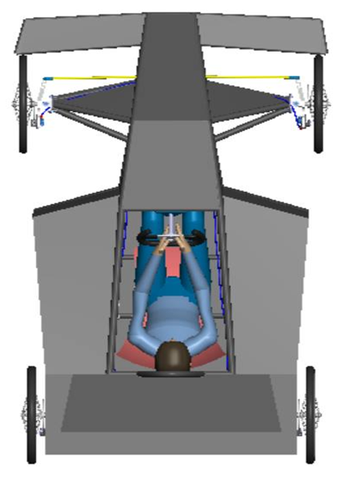

Upside view of the vehicle

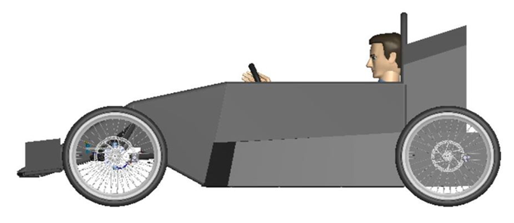

Side view of the vehicle

## Dimensions

The total mass of the vehicle is estimated to be approximately 60 kg without the driver.

The vehicle has the following overall dimensions:

Length: 2322 mm

Width: 1220 mm

Height: 980 mm

## Chassis, CAD model

The chassis is made by aluminium tubes Ø32 and Ø25. It is proiected to sustain a big mass of weight and to protectect the driver.

The chassis is presented in this images:

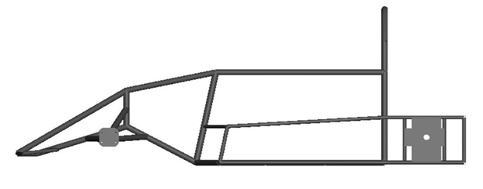

Side view of the frame

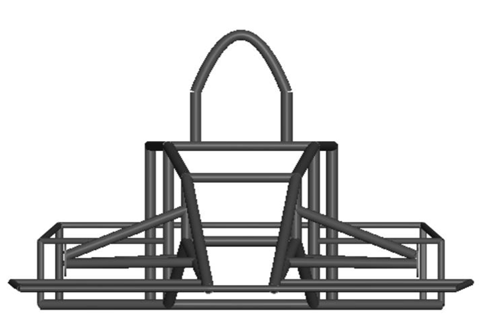

Front view of the frame

.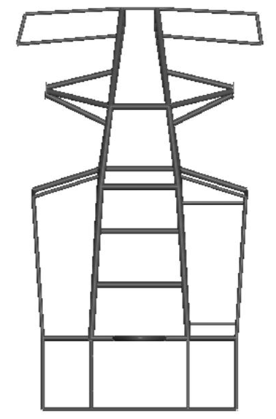

Top view of the frame

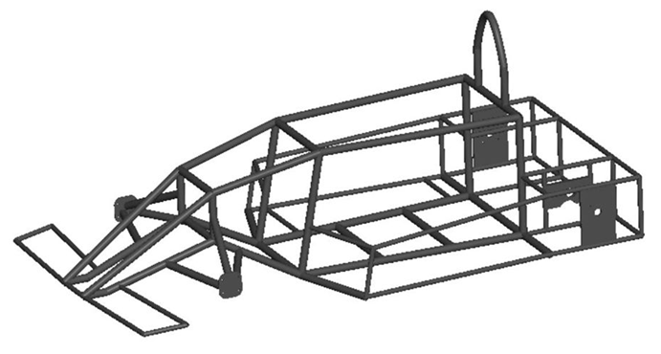

Perspective view of the frame

## Design of body, starting plates

The body has a special designed inspired by a F1 car. It is made by ABS and it is adapted for aerodynamics specific for the pneumatic vehicle.

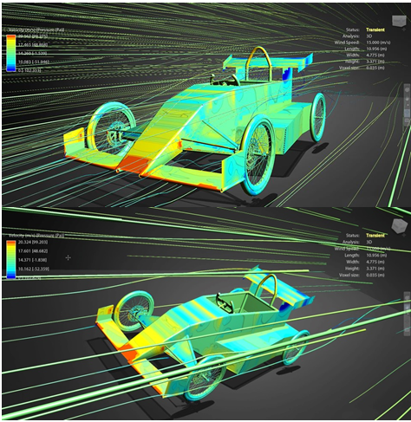



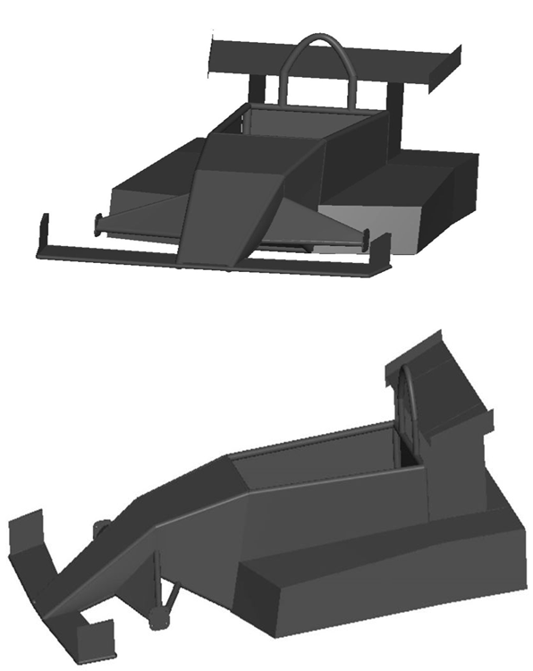



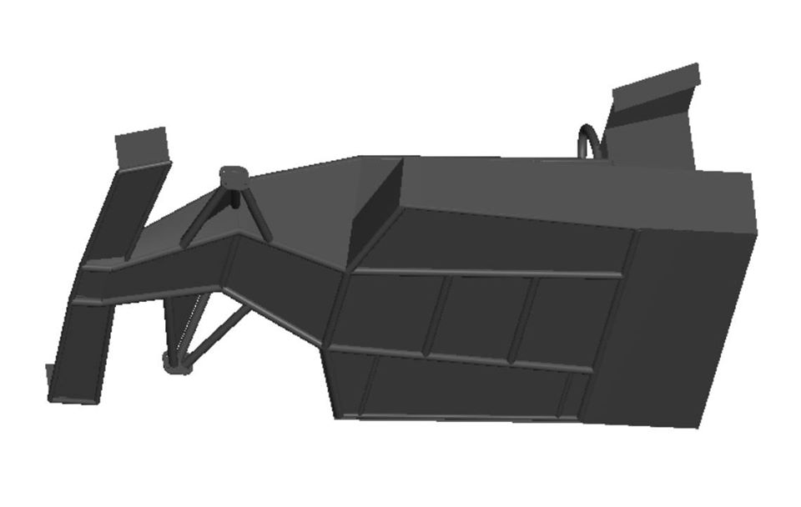

# Engine and drive chain

## Engine construction

The engine consists of two pistons. The first is Ø50 and the second is Ø63. The pistons can be moved individually. They operate the shaft with two ratchets and a sense switch.

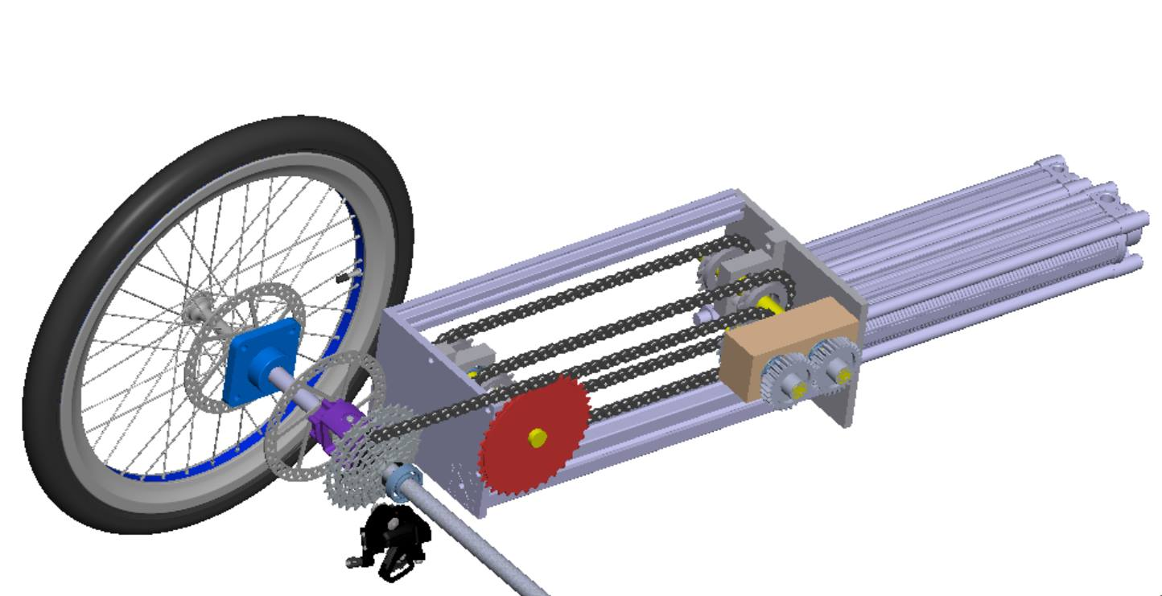

The engine has 4 modes:

* The first mode is with air recovery, the air from the 50 piston enters the 63 piston.
* The second mode is eco, the engine only works with the 50 piston.
* The third mode is turbo, both pistons are supplied simultaneously with air
* The fourth mode is the ecoboost, which uses the partial filling of the first piston with air recovery.

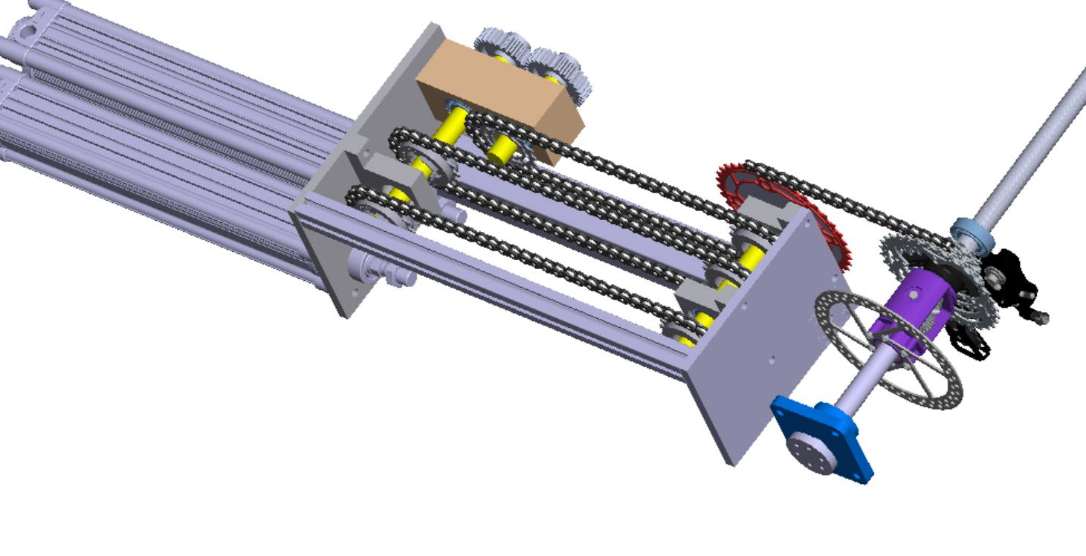

## Drive Chain

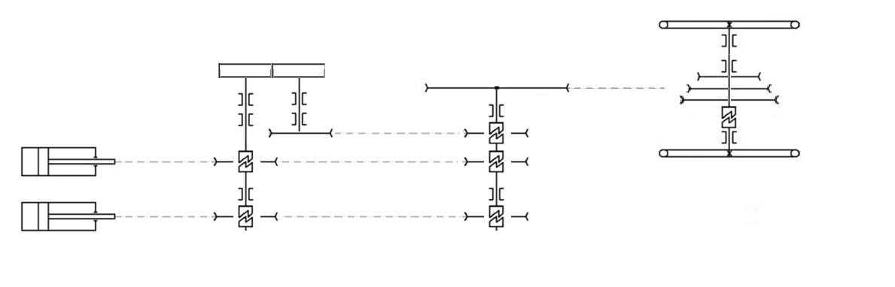

## Calculation

The cylinders used have a Ø50mm piston and a 125 mm stroke, so:

Knowing that the pneumatic system is running at 10 bars (1000 kPa), we will calculate the force that is obtained from the pressure over the piston area,

F = p π d2/ 4

    = (106 N/m2) π (0.025 m)2 / 4

    = 490 N

    = 0.490 kN

Knowing that only 2 pistons produces force per half a cycle, we will find the moment produced on the crankshaft,

(490 N 2) * 0.05m= 49 Nm

The dimensioning computation of the pneumatic cylinder, has started for the requirement witch we imposed of reaching 30 km/h in 10 seconds.

Initial dimensioning data are:

$$m_{p }≅50 kg -average weigh of the pilots$$

$$m_{a}≅70kg -weight of the pneumobile$$

$$μ=0,04 -overall friction coefficient$$

$$p=10 bar -maximum pressure available$$

To calculate the cylinder piston section (see Figure 3.8) will use relationship bellow

$$F=p∙S -where F is the necesary force at the pisto\overset{̕}{n}srod$$

$$S=\frac{F}{p}$$

$$S=\frac{π∙D}{4}d^{2}$$

$$D_{d}=\sqrt{\frac{4∙F}{π∙p}}$$

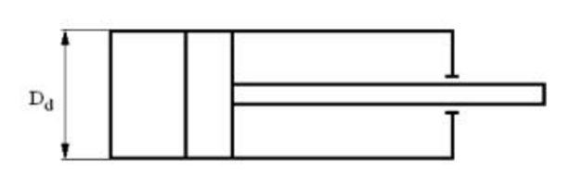

This force F is determined by overcoming $M_{t}$ resistance moment given by the inertia moment $M_{i}$ of the vehicle having a maximum mass (vehicle mass plus the mass of the car driver) to witch it adds resistance moment given by friction force and the moment given by the air advance.

$$m_{t}=m_{a}+m_{p}$$

$$m_{t}=40+80=120 kg$$

So the moment will be:

$$M_{t}=\frac{D_{r}}{2}(F_{i}+F_{f}+F_{a})$$

$M_{t}$-total time

Drive –rear wheel diameter of the vehicle

$F_{i}$–force given by the system inertia

$F_{f}$–friction force

$F_{a}$–drag force given by the airflow resistance

$$F_{i}=m_{t}∙a$$

$$F_{f}=m_{t}∙μ$$

$$F_{a}=\frac{1}{2}∙ρ∙C_{d}∙A∙v^{2}$$

Where:

$ρ$-air density

A -projection area on a front surface of the front surface

v – Velocity

$C_{d}$–aerodynamic coefficient of the vehicle

Physical data for moist air:

|  |  |  |  |  |  |  |
| --- | --- | --- | --- | --- | --- | --- |
| Temperature | Density | At 0˚C-t˚C | At 0˚C-t˚C | Water vapor pressure | Moisture content at saturation xs | Heat content at saturation is |
| ˚C | Kg/ $m^{3}$ | $$m^{3}$$ | $$m^{3}$$ | mmHg | g/kg dry air | kcal/kg |
| -10 | 1,396 | 0,963 | 1,038 | 1,95 | 1,60 | -1,45 |
| -5 | 1,368 | 0,982 | 1,019 | 3,01 | 2,47 | 0,26 |
| 0 | 1,342 | 1,000 | 1,000 | 4,58 | 3,78 | 0 |
| 5 | 1,317 | 1,018 | 0,982 | 6,54 | 5,40 | 4,42 |
| 10 | 1,293 | 1,037 | 0,965 | 9,21 | 7,68 | 6,97 |
| 15 | 1,226 | 1,055 | 0,948 | 12,79 | 10,6 | 9,98 |
| 20 | 1,205 | 1,073 | 0,932 | 17,53 | 14,7 | 13,8 |

**Tabel 1**

The value of $ρ$ at 20˚ will be extracted from tabel 1

$$ρ=1,205 kg/m^{3}$$

A - area will be taken as value ${A=1m}^{2}$

$C_{d}$ coefficient will be chosen from tabel 2

**Tabel 2**

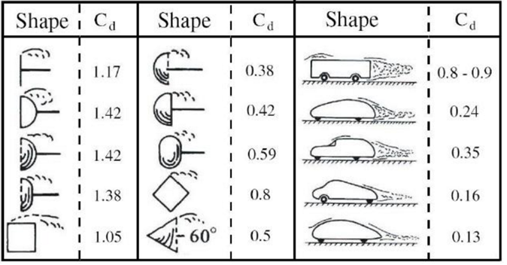

$$C_{d}=1,17$$

$$M_{t}=\frac{D_{r}}{2}\left|(m_{t}∙a+m_{t}∙μ+\frac{1}{2}∙ρ∙C_{d}∙A∙v^{2})\right|$$

Necessary acceleration to reach the speed of 30km/h is determined by the relation:

$$a=\frac{v_{f}-v_{i}}{t}$$

$$a=\frac{30∙1000}{5∙3600}=1,66$$

$${a=1,66 m/s}^{-2}$$

So the moment will be:

$$M_{t}=\frac{0,5}{2}\left|(120∙1,66+120∙0,04+\frac{1}{2}∙1,205∙1,17∙1∙{5,55}^{2})\right|$$

If the cylinders make the 320 mm stroke in a second the maximum speed of the vehicle will be 42 km / h.

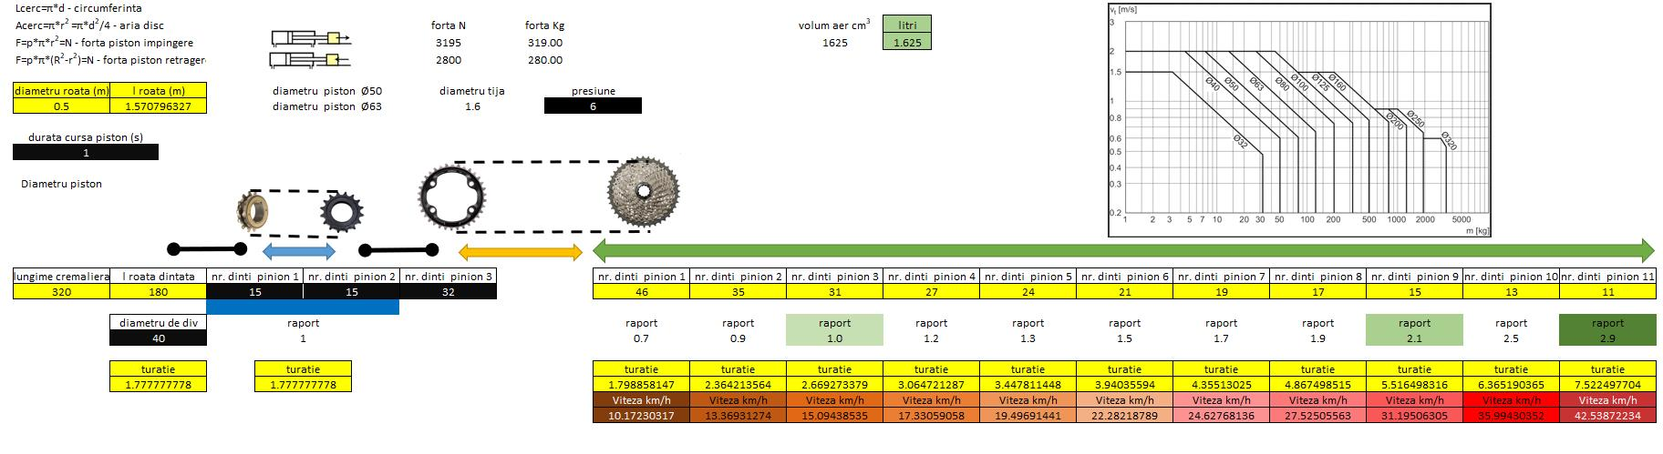

If the cylinders make the 320 mm stroke in a half a second the maximum speed of the vehicle will be 85 km / h.

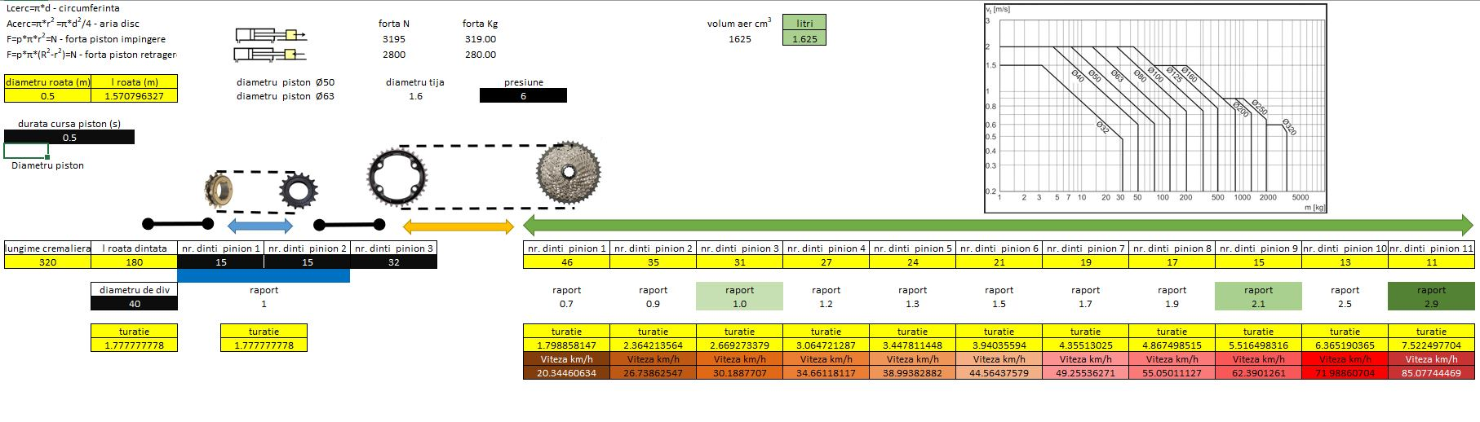

# Control system

## Pneumatic scheme

The pneumatic diagram is composed of:

* The safety system provided by Emerson;
* The acceleration part will be electroinically using a solenoid valve;
* The control part of the 2 pistons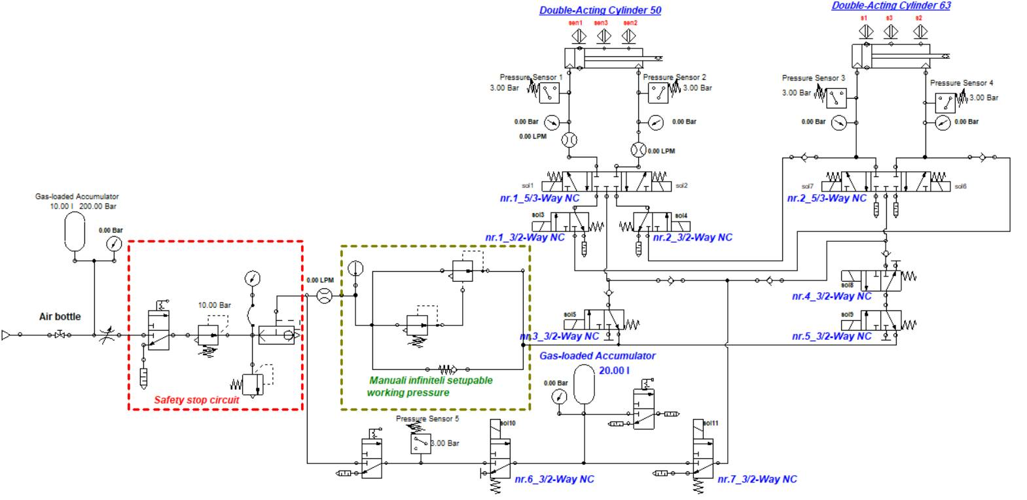

## BOM of Pneumatic scheme

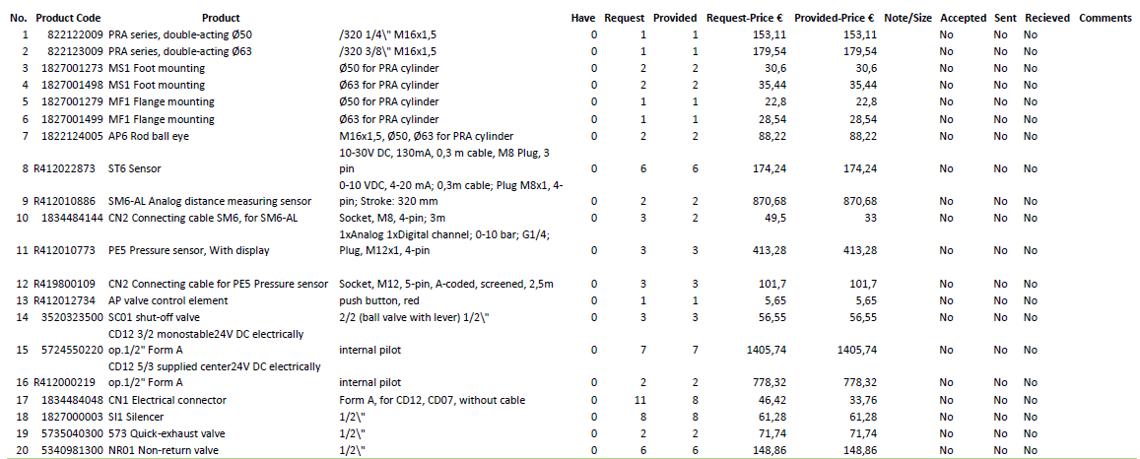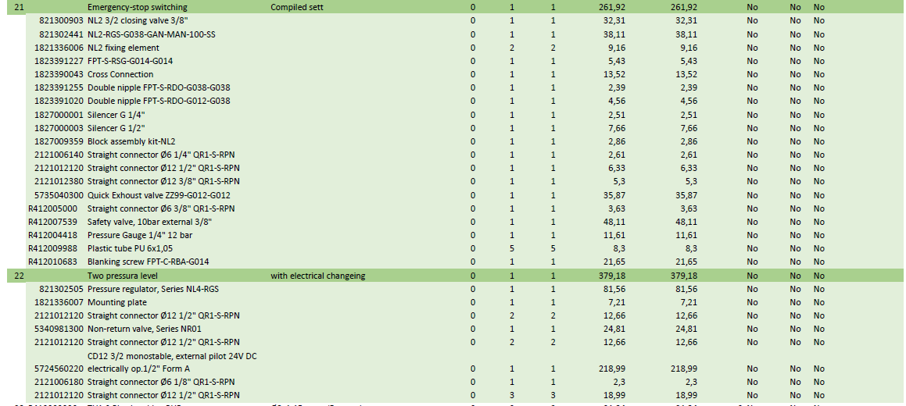

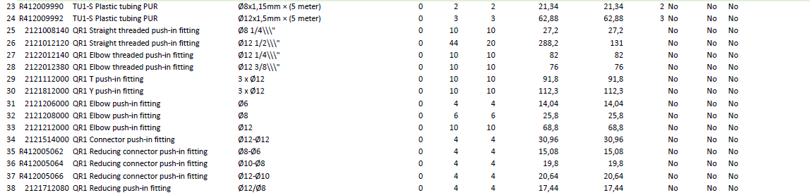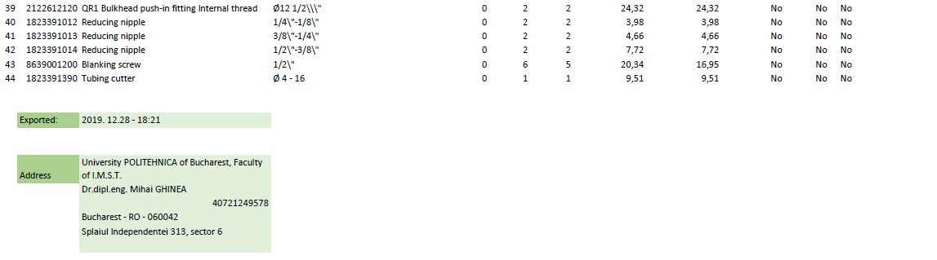

## Electronic scheme

The solenoid valve will be controlled with a Emerson PLC.

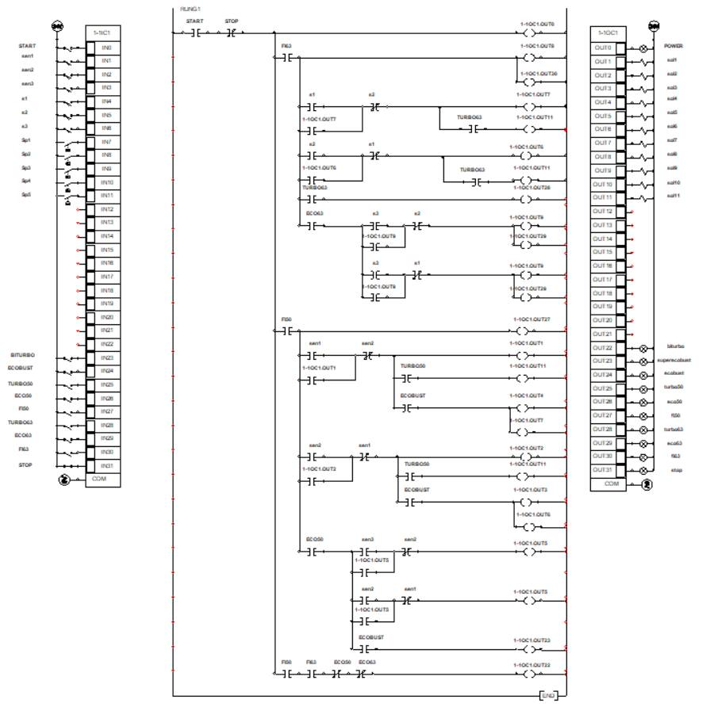

## Details of the control system

When the button fi63 is actuated, solenoid valve 3/2 no.4 receives the command releasing the air for solenoid valve 3/5 no.2. When the acceleration is actuated solenoid valve 3/5 no.2, it will supply the piston fi63 throughout the stroke.

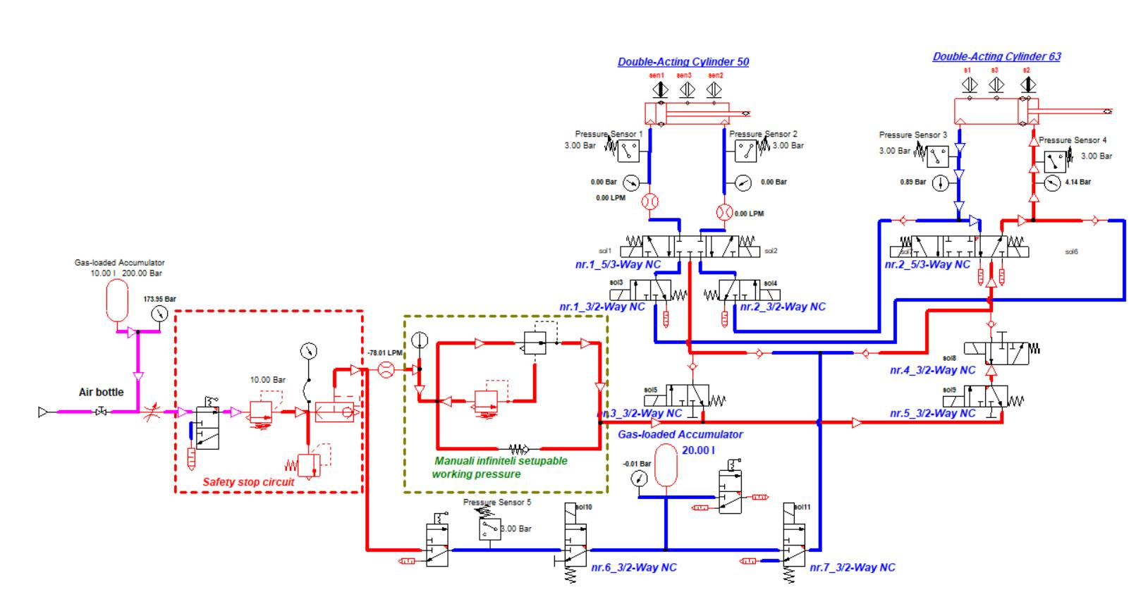

When the eco63 button is pressed, solenoid valve 3/2 no.5 will block the air of solenoid valve 3/2 no.4. Thus the piston fi63 will be partially filled by saving air.

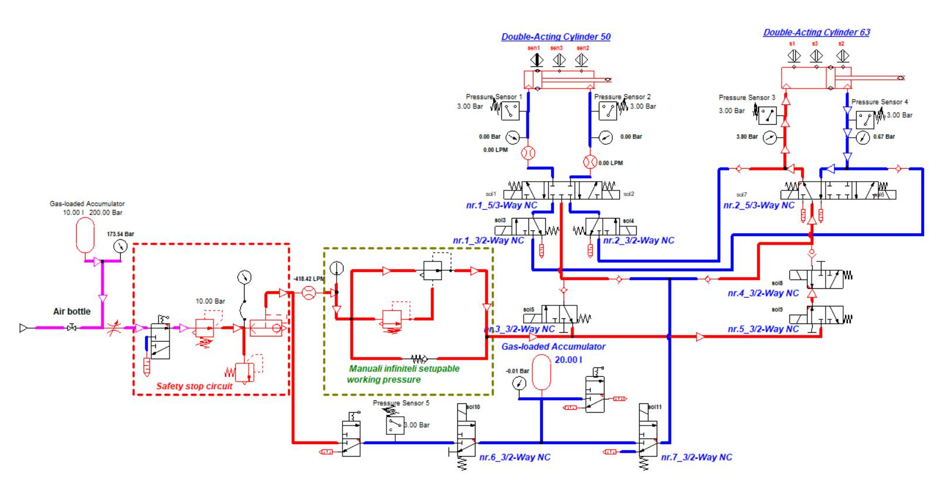

When the turbo63 button is pressed, the solenoid valve 3/2 no.7 on the supply with a high flow solenoid valve 3/5 no.2, thus the piston 63 can reach high speeds.

Solenoid valve no. 7 will receive the command only when the acceleration is pressed.

The buffer tank will be filled at the start of the race and during the race when the accelerator pedal is not actuated.

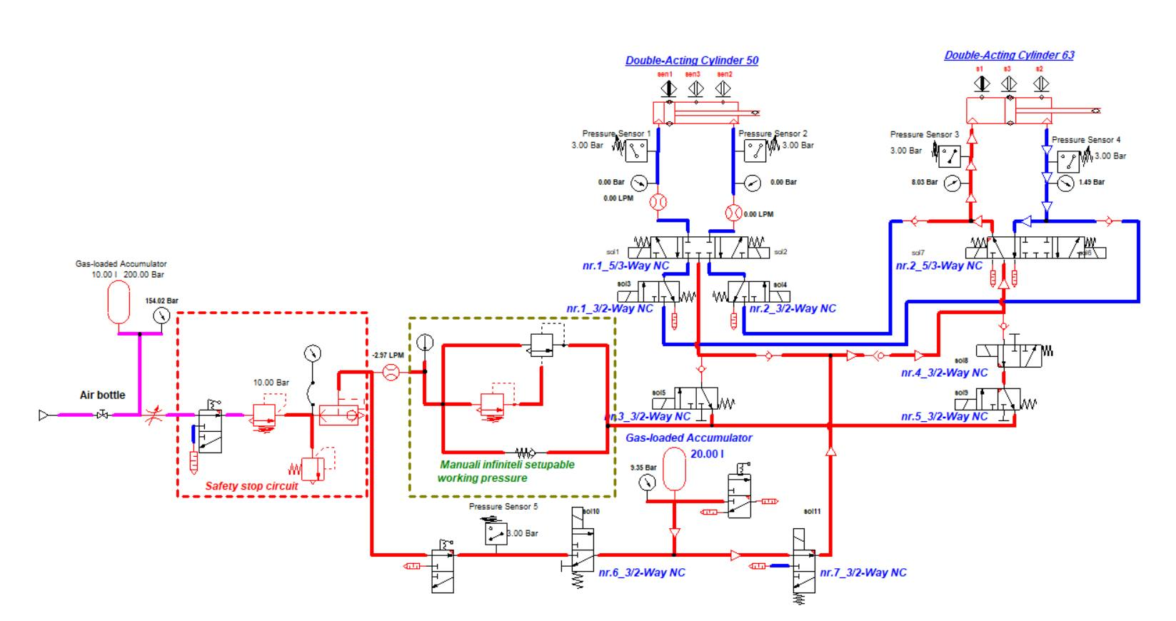

When the button fi50, is actuated solenoid valve 3/5 no.1. When the acceleration is actuated solenoid valve 3/5 no.1, it will supply the piston fi50 throughout the stroke.

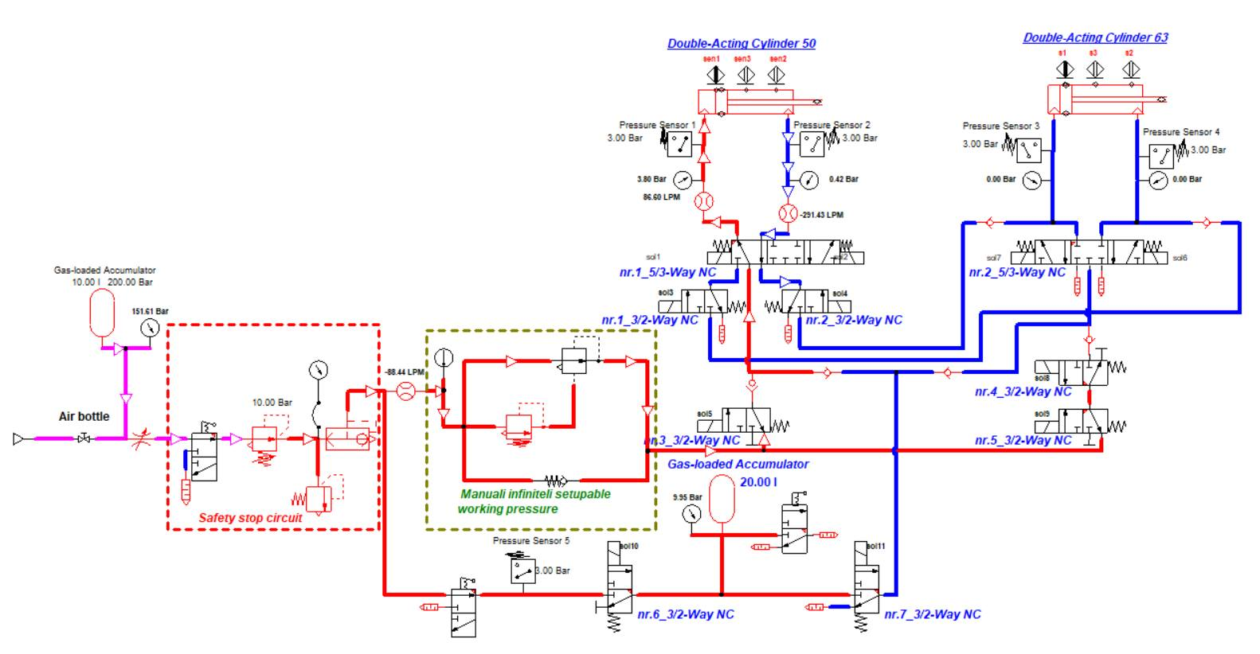

When the eco50 button is pressed, solenoid valve 3/2 no.3 will block the air of solenoid valve 3/5 no.1. Thus the piston fi50 will be partially filled by saving air.

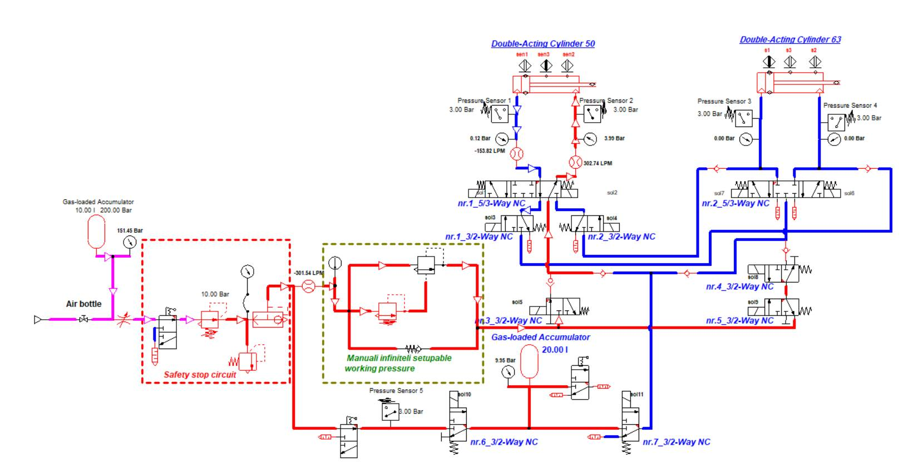

When the turbo50 button is pressed, the solenoid valve 3/2 no.7 on the supply with a high flow solenoid valve 3/5 no.1, thus the piston 50 can reach high speeds.

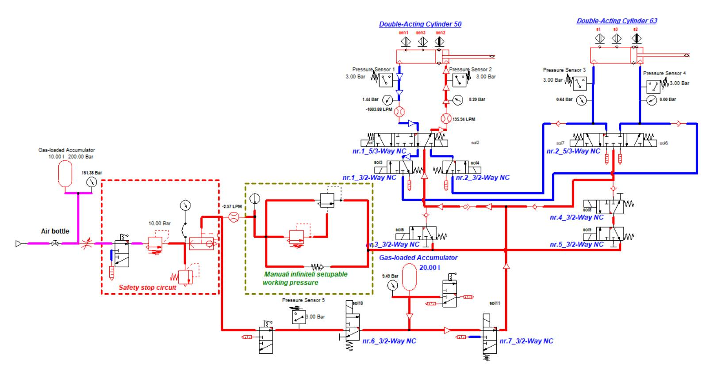

When the ecobust button is operated, solenoid valve 2/3 no.1 and solenoid valve 2/3 no.2 will direct the air coming out of the fiil cylinder 50 into the fi63 cylinder, thus increasing the power of the engine consuming air as well as for the small piston.

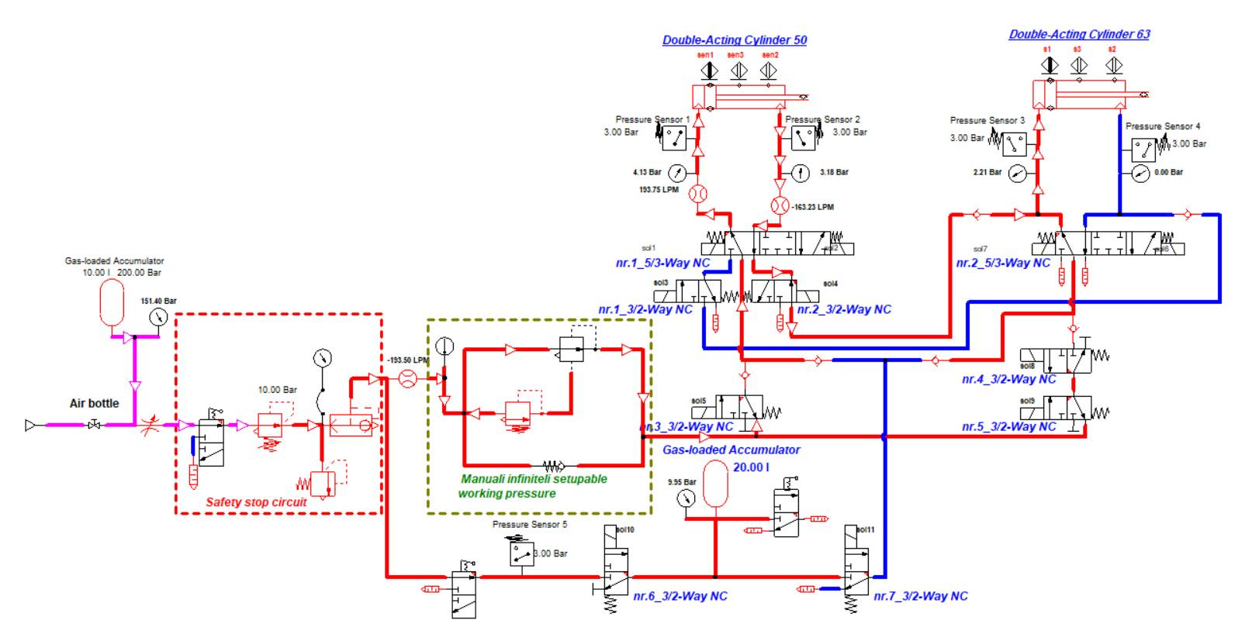

When the turbo button is pressed, the solenoid valve 3/2 no.7 on the supply with a high flow solenoid valve 3/5 no.1 and solenoid valve 3/5 no.2, thus the piston fi 50 and fi63 can reach high speeds.

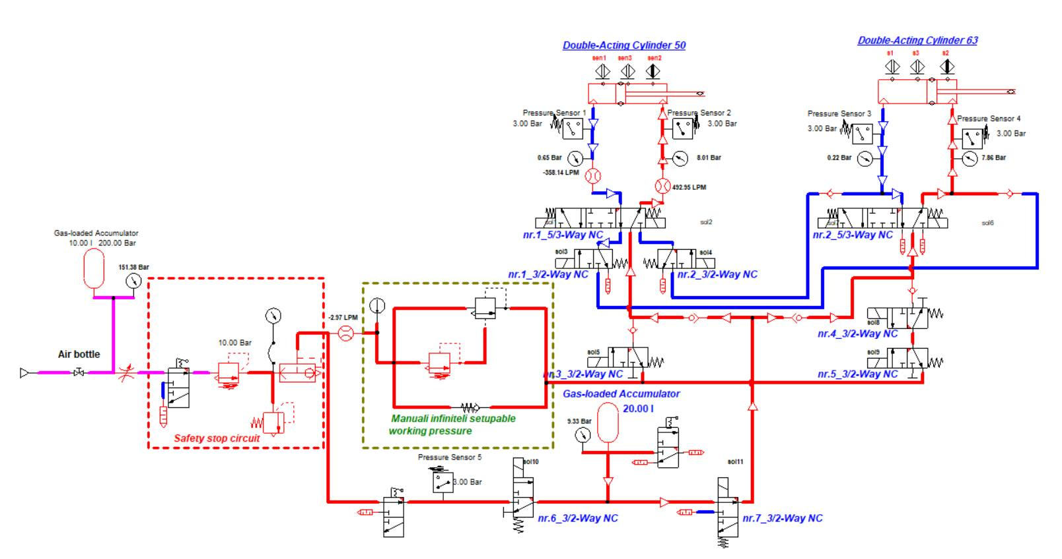

# Suspension, brake and steering system

## Front wheels

We do not have suspension on front wheels.

Front wheels are 20" bicycle wheels.

Brakes on front wheels are composed by 2 brake rotors and 2 mechanical bicycle calipers.

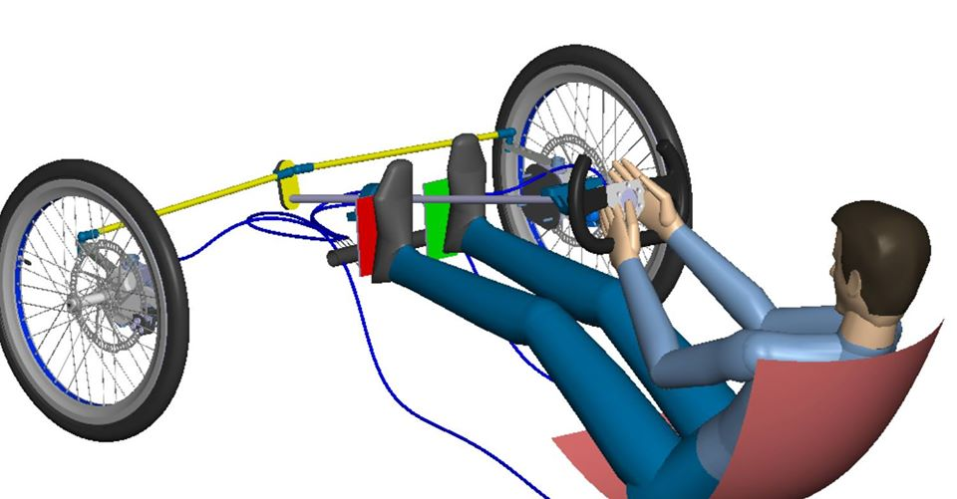

The brakes are actionated by the red pedal, which pulls the cable, operating the caliper that stops the vehicle.

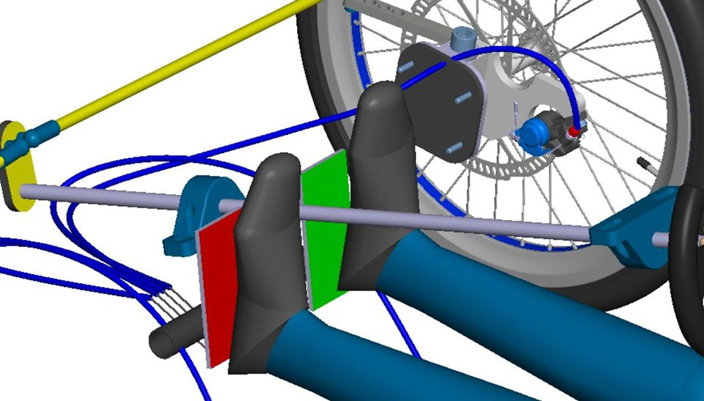

## Rear wheels

We do not have suspension on rear wheels.

Rear wheels are 20" bicycle wheels.

Brakes on rear wheels are composed by 2 brake rotors and 2 mechanical bicycle calipers.

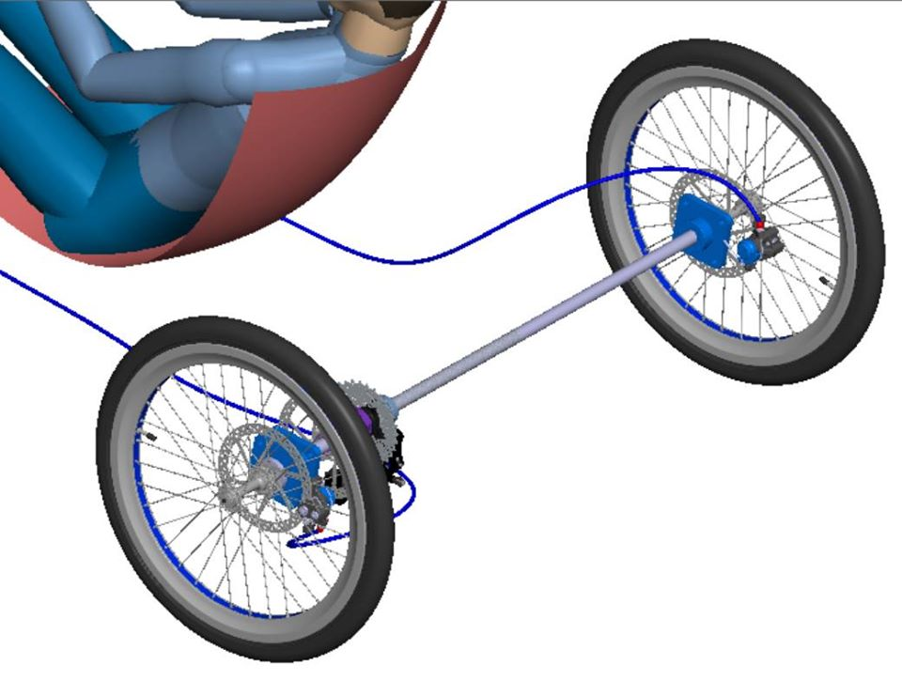

Rear brakes works as the front brakes. They are also actionated by the red pedal simultaneous with the front brakes.

## Steering system

The vehicle is driven by two wheels controlled by the driver through a steering wheel. The direction of rotation of the wheels is given by two rods, that are controled by the steering wheel trough a rod.

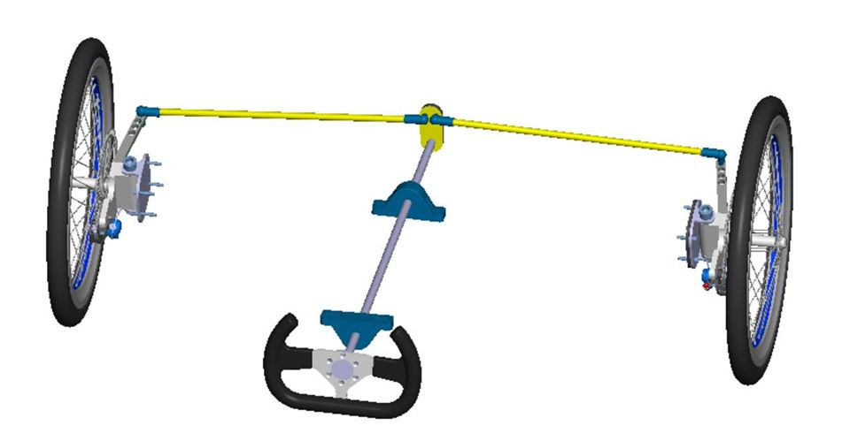

# Innovation

The complex pneumatic system. Partial piston filling as required by the force resulting from the required pressure read on the pressure sensor. Recovery of air from one piston to another. Use of additional air flow when the engine reaches the maximum pressure required.

Filling the buffer tank when the accelerator pedal is not actuated, and filling only when the pressure in the buffer tank is lower than the main tank.